**Measure energy consumption**

**Name: A S Sornambigai.**

**Mail ID:** akswarma66@gmail.com

A project report on

**Measure energy consumption**

Submitted in partial fulfillment of the requirements

for the degree of

**Bachelor of engineering**

In

**Bio medical engineering**

Under the guidance of

 **R.Nathea**

**Department of bio medical engineering**

**GRT Institute of engineering and technology**

**( Afflicted by Anna university)**

**Declaration**

**I** Rubini B hereby declar that the project report entitled Measure energy consumption done by me under the guidance of R nathea is submitted in partial fulfillment of the requirements for the award of bachelor engineering and technology degree in bio medical engineering.

SORNAMBIGAIA.S

SIGNATURE OF THE CANDIDATE

**TABLE OF CONTENT**

|  |  |  |
| --- | --- | --- |
| **Sl.No.** | **Title** | **Page no.** |
| 1 | Introduction | 5 |
| 2 | Aim | 6 |
| 3 | Task | 7 |
| 4 | Methodology | 8 |
| 5 | Sample program | 9 |
| 6 | Extract the Dataset | 11 |
| 7 | Preprocessing | 13 |
| 8 | Feature engineering | 14 |
| 9 | Innovation technique to predict future energy consumption | 16 |
| 10 | Block diagram | 17 |
| 11 | conclusion | 18 |

**Introduction:**

* Measuring energy consumption is vital for understanding, managing, and optimizing energy use.
* It involves quantifying the amount of energy utilized by various systems, devices, or activities, typically measured in units like kilowatt-hours (kWh) for electricity or therms for natural gas.
* This process enables individuals, businesses, and governments to track, analyze, and control their energy usage, fostering efficiency, cost savings, and environmental sustainability.
* Various tools and technologies, such as smart meters and energy monitoring systems, help in this measurement process, allowing for better decision-making and resource allocation.

**AIM:**

1.The primary aim of this study is to address the need  
for precise and comprehensive measurement  
of energy consumption. Specifically, we aim to:  
  
2.Develop efficient and accurate methodologies and  
tools for measuring energy consumption across  
various sectors, including residential, commercial, and  
industrial.  
  
3.Analyze the benefits of effective energy measurement,  
such as cost savings, carbon footprint  
reduction, and improved energy resource management.  
  
4.Identify challenges and barriers in current energy  
measurement practices and propose solutions to  
overcome them.  
  
5.Promote awareness and understanding of the  
significance of measuring energy consumption  
  
among individuals, organizations, and policymakers.

**Task:**

Utility Bills :

Reviewing your utility bills is a fundamental method to measure energy consumption. These bills typically include data on your electricity, gas, and water usage over a specified period.

 2. Energy Meters:

Consider installing energy meters, including smart meters if available in your area. Smart meters provide real-time data on your energy consumption and are often offered by utility companies.

 3. Appliance Monitoring:

For a more granular approach, use energy monitoring devices to track individual appliance usage. Smart plugs and devices designed for this purpose can provide valuable insights.

 4. Online Tools:

Many utility providers offer online tools and mobile apps that enable you to track your energy consumption trends and patterns conveniently.

 Comprehensive Energy Measurement

 5. Home Energy Audit:

Consider conducting a professional home energy audit. These audits provide in-depth assessments of your home's energy use and suggest strategies for improving efficiency.

 6. Energy Monitoring Systems:

Invest in a comprehensive energy monitoring system for a holistic view of your energy usage. These systems often include central displays and smartphone apps for detailed insights.

7. Energy Consumption Trends:

 Present key findings regarding energy consumption trends in AI.

 Include data on energy usage in AI hardware, data centers, and specific AI workloads.

8. Challenges and Considerations:

   a. Hardware Heterogeneity: AI systems can use a mix of CPUs, GPUs, and other accelerators, making measurement complex.

   b. Dynamic Workloads: Energy consumption can vary significantly depending on the AI workload's intensity.

   c. Scalability: Measuring energy consumption at scale for large AI deployments can be challenging.

   d. Accuracy: Achieving accurate measurements may require sophisticated tools and expertise.

9. Case Studies:

   a. Highlight real-world examples of organizations or research projects that have successfully measured AI energy consumption and its impact.

10. Future Directions:

    Discuss emerging trends and technologies for more accurate and efficient energy measurement in AI.

    Consider the potential impact of AI-specific hardware advancements.

11. Importance of Measuring AI Energy Consumption:

   a. Environmental Impact: The energy consumption of AI systems contributes to carbon emissions and environmental degradation.

   b. Cost Efficiency: Accurate measurement helps organizations optimize their AI deployments for cost savings.

   c. Regulatory Compliance: In some regions, there are regulations concerning energy efficiency and reporting.

 12. Factors Affecting AI Energy Consumption:

   a. Hardware: The type of hardware used (e.g., CPUs, GPUs, TPUs) plays a significant role.

   b. Software: Algorithm efficiency and software optimization are crucial.

   c. Workload: Energy usage varies based on the AI workload (e.g., training vs. inference).

**Methodology:**

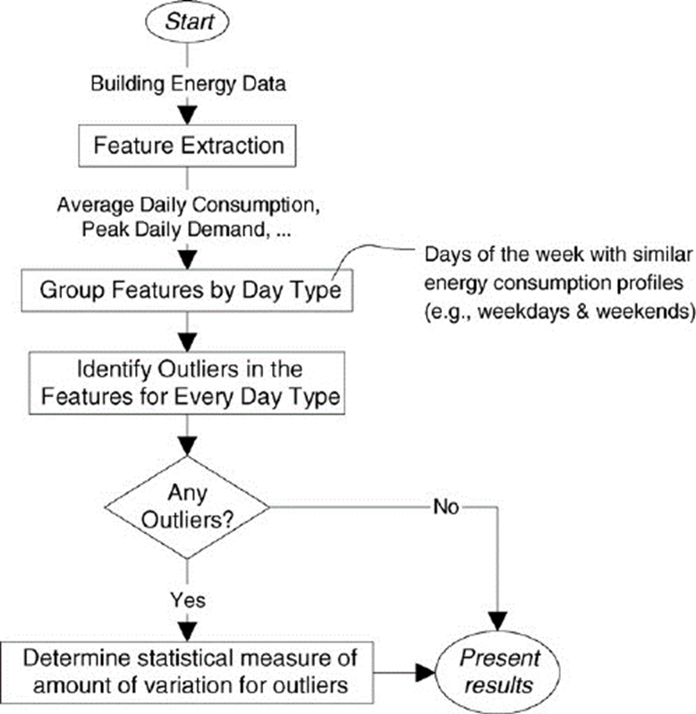

**Formula:**

E = P*(t/1000); where E = energy measured in Joules or kilowatt-hours (kWh), P = power units in watts, and t = time over which the power or energy was consumed.

**Sample Programe:**

# Create a list to store monthly energy consumption data in kWh  
monthly_consumption = [500, 600, 700, 550, 750, 800, 700, 600, 650, 700, 550, 600]  
# Calculate the total annual energy consumption  
total_consumption = sum(monthly_consumption)  
# Calculate the average monthly consumption  
average_monthly_consumption = total_consumption / len(monthly_consumption)  
# Calculate the maximum monthly consumption  
max_monthly_consumption = max(monthly_consumption)  
# Calculate the minimum monthly consumption  
min_monthly_consumption = min(monthly_consumption)  
  
# Print the results  
print(f&quot;Total Annual Energy Consumption: {total_consumption} kWh&quot;)  
print(f&quot;Average Monthly Energy Consumption: {average_monthly_consumption} kWh&quot;)  
print(f&quot;Maximum Monthly Energy Consumption: {max_monthly_consumption} kWh&quot;)  
print(f&quot;Minimum Monthly Energy Consumption: {min_monthly_consumption} kWh&quot;)  
  
**OUTPUT:**Total annual energy consumption:7700 kwh  
Average monthly energy consumption: 641.666666666 kwh  
Maximum monthly energy consumption: 800 kwh  
Minimum monthly energy consumption: 500 kwh

**Done by the program:**

* **Use this website**[https://www.programiz.com/python-programming/online-compiler/](https://www.programiz.com/python-programming/online-compiler/#inbox/_blank) done the program.

* To type the programe in this website and done the program.
* If any error occur the error and run the program.
* 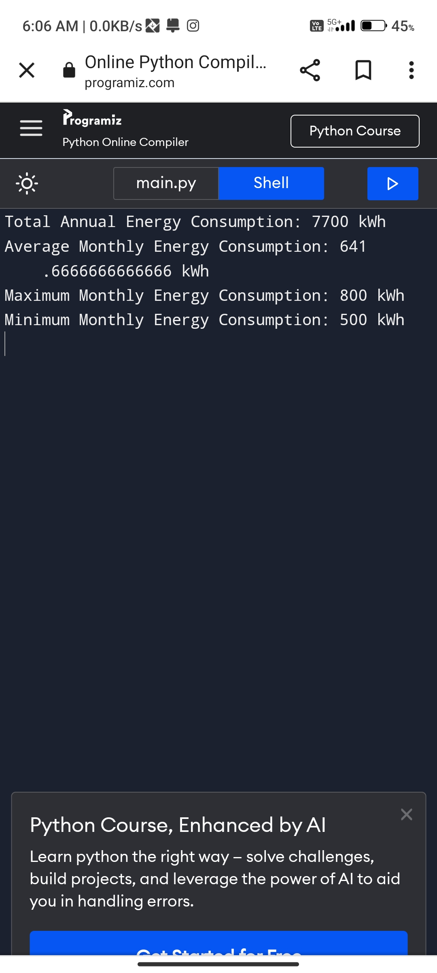

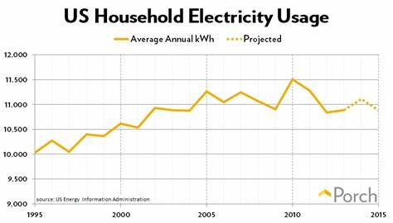

To measure monthly total energy consumption for a house in Python, you’ll need data on energy usage,

typically in kilowatt-hours (kWh), and a way to process that data. Here’s a basic example of how to do

this:

# Sample energy usage data for each month (you would replace this with your actual data)

Energy_data = {

“January”: 350,

“February”: 400,

“March”: 375,

“April”: 320,

“May”: 310,

“June”: 330,

“July”: 360,

“August”: 380,

“September”: 390,

“October”: 370,

“November”: 350,

“December”: 400,

}

# Calculate the total energy consumption for the year

Total_energy = sum(energy_data.values())

# Print the result

Print(f”Total energy consumption for the year: {total_energy} kwh”)

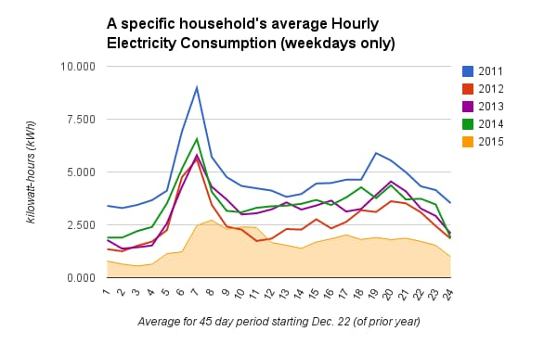

**Extract The Dataset:**

In[1]:

Import pandas library

import pandas as pd

In[2]:

#Load data to be used into a dataset

filename='/kaggle/input/world-energy-consumption/World Energy Consumption.csv'

df_energy=pd.read_csv(filename)

df_energy_c=df_energy.copy()

In[3]:

#Analyze how many data there is in this dataset

df_energy_c.shape

Out[3]:

(17432, 122)

In[4]:

|  |  |  |  |  |  |  |  |  |
| --- | --- | --- | --- | --- | --- | --- | --- | --- |
|  | count | Mean | Std | Min | 25% | 50% | 75% | Max |
| year | 17432.0 | 1.973094e+03 | 3.433400e+01 | 1900.000 | 1946.000 | 1983.0000 | 2002.00000 | 2.020000e+03 |
| coal_prod_change_pct | 7445.0 | 2.083077e+01 | 6.971787e+02 | -100.000 | -1.532 | 0.0000 | 7.69000 | 4.496575e+04 |
| coal_prod_change_twh | 10394.0 | 8.798102e+00 | 1.355037e+02 | -2326.870 | 0.000 | 0.0000 | 0.33400 | 3.060593e+03 |
| gas_prod_change_pct | 4862.0 | 1.921623e+14 | 1.339910e+16 | -100.000 | 0.000 | 2.5835 | 9.70350 | 9.342930e+17 |
|  |  |  |  |  |  |  |  |  |
| gas_prod_change_twh | 7893.0 | 1.436902e+01 | 8.541565e+01 | -1054.320 | 0.000 | 0.0000 | 2.55900 | 2.112975e+03 |
| ... | ... | ... | ... | ... | ... | ... | ... | ... |
| wind_share_energy | 4284.0 | 3.454057e-01 | 1.337962e+00 | 0.000 | 0.000 | 0.0000 | 0.02000 | 2.066000e+01 |
| wind_cons_change_twh | 4207.0 | 2.163830e+00 | 1.701315e+01 | -10.409 | 0.000 | 0.0000 | 0.01000 | 4.287360e+02 |
| wind_consumption | 4290.0 | 1.508094e+01 | 1.266741e+02 | 0.000 | 0.000 | 0.0000 | 0.14100 | 3.540051e+03 |
| wind_elec_per_capita | 5499.0 | 5.362578e+01 | 2.095435e+02 | 0.000 | 0.000 | 0.0000 | 3.04650 | 2.825425e+03 |
| wind_energy_per_capita | 4290.0 | 1.340031e+02 | 5.133680e+02 | 0.000 | 0.000 | 0.0000 | 4.74475 | 6.928363e+03 |

#Analyze this data set with 'describe'

df_energy_c.describe().T

Out[4]:

120 rows × 8 columns

In[5]:

#Understand which columns there are in this dataset

df_energy_c.columns

Out[5]:

Index(['iso_code', 'country', 'year', 'coal_prod_change_pct',

       'coal_prod_change_twh', 'gas_prod_change_pct', 'gas_prod_change_twh',

       'oil_prod_change_pct', 'oil_prod_change_twh', 'energy_cons_change_pct',

       ...

       'solar_elec_per_capita', 'solar_energy_per_capita', 'gdp',

       'wind_share_elec', 'wind_cons_change_pct', 'wind_share_energy',

       'wind_cons_change_twh', 'wind_consumption', 'wind_elec_per_capita',

       'wind_energy_per_capita'],

      dtype='object', length=122)

**Preprocessing**

As described in the previous section, some amount of preprocessing  
is required on typical data sets before they have all the necessary  
attributes to develop a model that accurately maps expected driving  
conditions to energy consumption. Depending on the shape of the

input data sets, preprocessing can include:

• Filter, cleanse, and standardize high resolution drive cycles  
• Simulate energy consumption  
• Map-match the spatial data to links in a road network.

**Feature engineering:**

**1. **Time-Based Features**:**

**-**Time of day: Split timestamps into categories like morning, afternoon, and evening.

   - Day of the week: Create binary variables for weekdays and weekends.

**-**Seasonality: Incorporate seasonal information, such as summer, winter, or holidays.

**2. **Weather Data**:**

**-**Temperature: Include current temperature or historical averages for the day.

   - Weather conditions: Encode weather conditions like sunny, rainy, or cloudy.

**3. **Historical Consumption**:**

**-**Lag features: Use past energy consumption data to create lag features, such as yesterday's consumption or the same day from the previous week.

**4. **Building Characteristics**:**

**-**Size of the building: Square footage or number of rooms.

   - Building age: How old is the structure?

   - Building type: Residential, commercial, industrial, etc.

**5. **Appliance Information**:**

**-**Number of appliances: Count and type of appliances in use.

   - Appliance efficiency: Energy rating of appliances.

**6. **Occupancy Data**:**

**-**Number of occupants: If available, use data on the number of people in the building.

**7. **Economic Factors**:**

**-**Energy prices: Incorporate local energy prices or tariffs.

**8. **Daylight Information**:**

**-**Sunlight exposure: Measure the amount of natural light in the building.

**9. **Categorical Variables**:**

**-**One-hot encoding: Convert categorical variables like location or building type into binary variables.

**10. **Feature Scaling**:**

**-** the process of normalizing the range of features in a dataset

**11. **Feature Interactions**:**

**-**Create interaction terms between relevant features, like temperature and HVAC usage.

**12. **Time Series Features**:**

**-**Rolling statistics: Compute rolling averages or sums over time windows.

    - Time since last event: Calculate the time elapsed since the last major event (e.g., maintenance).

**13. **Anomalies Detection**:**

**-**Identify and flag outliers or anomalies in the data, which can be important for understanding extreme consumption patterns.

**14. **Geospatial Information**:**

**-**Incorporate location-specific features, such as proximity to public transportation or urban vs. rural settings.

**15. **User Behavior**:**

**-**User interactions: If available, consider how user behavior affects energy consumption (e.g., turning on lights, adjusting thermostats).

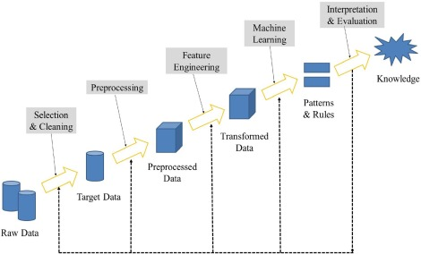

**Innovation technique to predict future energy consumption pattern:**

Predicting future energy consumption patterns is crucial for efficient resource management.

Time series analysis and machine learning can be powerful tools for this task.

1. **Time Series Analysis:**

 Start by collecting historical energy consumption data, including timestamps.

 Use techniques like Autoregressive Integrated Moving Average (ARIMA) or Seasonal Decomposition of Time Series (STL) to analyse and forecast energy consumption trends.

 Visualize the data to identify patterns and seasonality.

**2. Machine Learning Models:**

 Feature engineering is essential. Create relevant features like temperature, day of the week, holidays, etc., as they often influence energy consumption.

 Train regression models such as Linear Regression, Decision Trees, or Random Forests topredict energy usage.

For more complex relationships, consider using neural networks like Recurrent Neural Networks (RNNs) or Long Short-Term Memory (LSTM) networks, which are well-suited for time series data.

**3. Data Preprocessing:**

Normalize or scale the data to ensure consistent input to the models.

 Split the data into training and testing sets to evaluate model performance.

**4. Model Evaluation:**

 Use metrics like Mean Absolute Error (MAE) or Root Mean Square Error (RMSE) to assess the accuracy of your predictions.

Consider cross-validation techniques to ensure robustness.

**5. Real-time Data:**

If possible, integrate real-time data sources like weather forecasts or building occupancy to improve predictions.

**6. Continual Learning:**

 Implement techniques for continuous model improvement, such as updating the model with new data regularly.

**7. Deployment:**

 Deploy the model in a production environment, integrating it with monitoring systems to provide real-time energy consumption predictions.

**8. Feedback Loop:**

 Continuously gather feedback and adjust your models to account for changing patterns and improve accuracy.

 Remember that the effectiveness of these techniques depends on the quality and quantity of data available.

 Regularly update and refine your models to adapt to changing consumption patterns and external factors.

**Block diagram:**

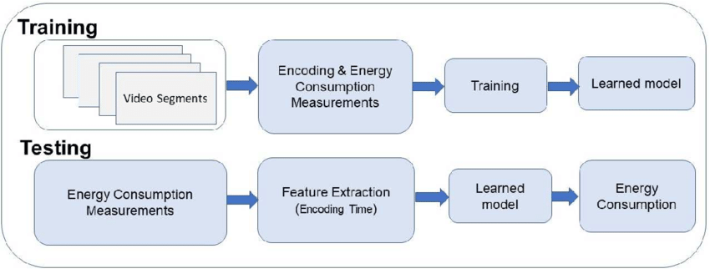

**Conclusion:**

The escalating global demand for energy presents a critical challenge and an opportunity for transformation. Addressing energy consumption is imperative to mitigate environmental impacts, ensure resource sustainability, and foster economic stability. To conclude, adopting a multi-faceted approach involving renewable energy sources, technological innovations, efficient infrastructure, and widespread public awareness is essential for a sustainable future. Collaboration between governments, industries, and individuals is pivotal in curbing energy consumption, paving the way towards a more sustainable and eco-friendly world.